Level of Integration (SSI, MSI, LSI)

The term "large scale integration" (LSI) was first used by IBM scientist Rolf
Landauer when describing the theoretical concept; that term gave rise to
the terms "small-scale integration" (SSI), "medium-scale integration"
(MSI), "very-large-scale integration" (VLSI), and "ultra-large-scale
integration" (ULSI).

Display Drivers

A Display Driver is software which enables communication between your computer and your monitor, or screen. The monitor connects to your computer via the display adapter, which is also known as a graphics card. Missing or corrupt drivers can cause problems with your display such as low or limited resolution, flickering or seeing horizontal lines.
Updating to the correct Windows driver version will fix these problems, and then you will have the right driver installed.

Code Converters

A code converter circuit will convert coded information in one form to a different coding form.
A code converter reads and interprets the input code and produces an equivalent output code according to its functionality. For example, a binary-to-decimal code converter takes a binary code as input and generates an equivalent decimal code as output.

Binary-coded Decimal.(BCD)
In computing and electronic systems, a binary-coded decimal (BCD) is a digital encoding method for decimal numbers in which each digit is represented by its own binary sequence.
BCD is different from converting a decimal number to binary. For example, 45, when converted to binary, is 101101, and when represented in BCD is 01000101.
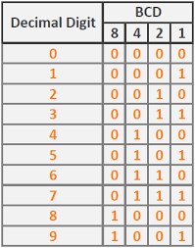

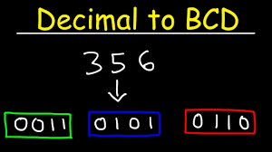
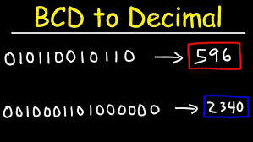

BCD number to Decimal number Conversion

To convert a BCD number to the decimal number, we need to start from the right and group the bits into 4 bits, and then replace every group of 4 bits by the equivalent decimal digit.

Example: Convert the BCD number 100001010111 to Decimal.

Solution:
Example of BCD to Decimal conversion
(100001010111)
BCD
= 85710
Example: Convert the BCD number 011110101000 to Decimal.

Solution:
Example of invalid BCD number
The given BCD number has one invalid code 1010, which is not a valid BCD number.
So, the given number is not a valid BCD number, and therefore, we can not convert it to decimal

Decimal number to BCD number Conversion.

To convert a decimal number to the BCD number, we need to replace every digit of the
decimal number by its 4 bit unsigned binary equivalent

.Example: Convert the decimal number 9673 to BCD.

Solution:
Example of Decimal to BCD Conversion
967310
= (1001_0110_0111_0011)BCD

Example: Convert the decimal number 96.73 to BCD.

Solution:
Example of Fractional Decimal to BCD Conversion
96.7310
= (10010110.01110011)

